INFOPACK
EUnique Project
TORREMOLINOS, SPAIN
7TH - 13TH NOVEMBER 2018


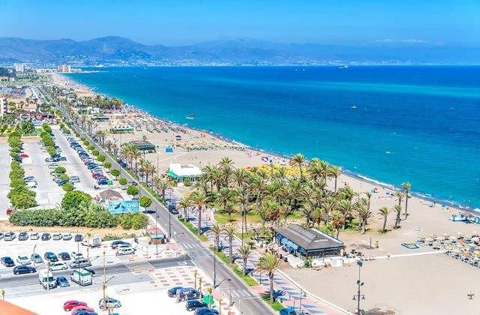

ABOUT TRAINING COURSE

  - European Union is nowadays at a crossroad, divided between the need to remain faithful to its core democratic values and freedoms, maintaining an area of freedom and justice and the need to protect its citizens against the new terrorism and the rise of nationalistic leaders and parties that require less Europe and more power back to the nation states. In many European countries public discontent against traditional political parties is rising, and at the same time there is a growing consensus for anti‐establishment protest movements with populist undertones. In this cauldron of discontent, certain politicians are flourishing and even gaining power by portraying rights as protecting only the terrorist suspect or the asylum seeker at the expense of the safety, economic welfare, and cultural preferences of the presumed majority. They scapegoat refugees, immigrant communities, and minorities. Nativism, xenophobia, racism, and Islamophobia are on the rise.
Europe has always struggled with conflicting visions of its identity, of a unifying idea that will erase national particularities, a generous idea with such irreducible values. We are witnessing now, after a long process of integration, a return to instinctive national sentiments. In the face of fear, people want to feel safe; hence a leader who can promise security and protection is gathering the popular support.
This is why EU commission and European leaders have decided to meet on 17 November 2017 in Gothenburg to discuss the future role of education and culture in strengthening the sense of belonging together, European identity and being part of a cultural community. So, the reflection about the future of our Union also entails a reflection on the strength of our common identity. Having all this in mind, the desired impact is to strength the sense of belonging together in order to prevent the flaring-up of populism and xenophobia and the risk of violent radicalisation. Consequently, the main aim of “EUnique project” is to equip youth workers with competences and methods needed for transferring the common fundamental values of our society in their local context, particularly to the hard to reach young people.

  - The project will use non formal learning methodology including methods such as: ice breakers, energizers, name games, reflection groups, working into intercultural subgroups, facilitated discussion, creative presentations, simulation, case study, and debates.

  - The project will involve 14 participants, 2 for each of the Partner Countries and 4 for Spain between 18-35 years old. The project is implemented by 6 organisations and financed by the European Commission through Erasmus+ programme.

ABOUT THE ORGANIZER

Asociación PROJUVEN is a Spanish youth NGO active at European level whose mission is to empower young people to change their community.

PROJUVEN means proyecto juvenil (youth project). It stands for something dynamic. We are organization, which creates opportunities for young people who would like to be an active, try and learn something new and gain new experience and knowledge for personal and professional development. We want to enrich the educational, social and cultural life of young people living in our country, mainly young people with fewer opportunities. We believe that young people must become a driving force in building the society in which they live and therefore we create various opportunities in order to help shape a generation that is determined to change our country/and world for the better.

IN THE PRESENT DAY:

PROJUVEN coordinate the KA2 project "eSkills for Volunteers" Strategic partnership in the field of youth. We are also partner with a leading role in another 8 KA2 projects: “Entrepreneurship Education for Cultural Tourism”, “IMCE skills”, “EuroIMPACT Plus”, TURN ONline, Volunteer 4 ALL, Radical Online Education, “Tackle Hate” and “Entrepreneurship 4 youth” and we have also 4 Capacity Building project with partners from (EU, Asia and Latin America).

For more info you can take a look also at our FB page.

PROJECT TIMELINE

Training Course: 7-13 November; Torremolinos (Malaga), Spain
9th July 2018 | Infopack release  Call for participants opening
20th August 2018 | Deadline for participants selection
5th September 2018 | Deadline for travel arrangement
7th October 2018 | Participants preparation (content, culture and organisation representation). Project partners have to ensure that participants had read the infopack, get with them their European Health Card etc.
7-13 November 2018 | Activities take place
Visibility, dissemination & multiplication activities. December 2018 on: Project partners have to disseminate project results and activities in their website and social media channels

- TARGET GROUP

4.1. The number of participants for each partner:
Country | Organisation | Number of Participants
SPAIN | Asociación PROJUVEN | 4
DENMARK | Danish Youth Team | 2
SLOVAKIA | A.D.E.L. - ASSOCIATION FOR DEVELOPMENT, EDUCATION AND LABOUR | 2
ROMANIA | ASOCIATIA GEYC | 2
HUNGARY | Kulturális Kapcsolatokért Alapítvány | 2
POLAND | FUNDACJA WSPIERANIA INICJATYW ROZWOJU LOKALNEGO | 2
TOTAL: |  | 14

For the participants’ selection the following criteria will be taken into consideration:

  - Mix of existing and experienced youth workers but also youth workers who are new or newish to the topic;

  - Demonstration of social sensibilities (socially active youth workers/leaders with a role in local communities and interested in transferring the common fundamental values of our society in their local context);

  - Experienced or interested in working with Erasmus+ programme;

The participants will have the following tasks:
    - To complete the Participant’s mobility report sent by EU
    - Make at least one publication or article, presentation or other/online (on organization website, Facebook or other social network)
    - Everything else that you could do or organize as a dissemination of the project will be warmly welcomed and appreciated from us.

  - We encourage participants of all eligible ages to take part in our project.

Regarding gender balance, we shall take care that the proportion of females and males participating to be close to 50%/50%.

  - Moreover, equality of chances is one of the values shared by Asociación PROJUVEN and its partners; we will not tolerate any kind of discrimination throughout this project, especially regarding the selection of the participants.

  - The main selection criteria will be participants' motivation.

  - On National Agency request, the partner organisations have to be able to justify the integration of their representatives in the target group. Only the participants belonging to the target group could be funded in the frame of this project.

  - The Youthpass will be released at the end of training to all participants;

PARTICIPANTS REGISTRATION

The legal representative or the contact person will need to send a nomination declaration as follows:
- Subject: [EUnique Project][Nomination] - Your organisation - Your country
- E-mail to: mobility-office@projuven.org
- E-mail body will look like this:
- Deadline: 20th August 2018

Declaration

I, the undersigned, .................................................. (First name, Last name, function) as the
legal representative of ............................................ (Name of the Partner organisation),
................................... (PIC number), from ............................. (Country) taking into
consideration that my organisation is an official partner of “EUnique project”, project coordinated by Asociación PROJUVEN (Spain) and financed by the European Commission through Erasmus+ programme, I hereby declare the followings:

- The following participant(s) is/are entitled to take part to the Training Course and to represent our organization:

First name | Last name | Birth date | E-mail address

- They respect all the following eligibility conditions:

- They belong to the project target group as described in the infopack;
- They are not beneficiaries of an Erasmus student scholarship at the moment of the activity;
- They are not on European Voluntary Service (EVS) at the moment of the activity;
- They are legal residents in the country where our organization is registered; and in case that is proven otherwise we are ready to fully cover all the costs inquired.

- We are aware that each participant at the mobility would need to fill in an electronic individual report (on the platform Mobility Tool+) within 7 days after the activity.

- PURCHASE OF TRAVEL TICKETS
- On their own costs, participants are allowed to arrive and to stay 2 extra days outside the project duration and have their flight reimbursed. However, in this case, they have to pay the extra days of hotel.

- As soon we receive the nomination declaration from the legal representative of your organization, you are kindly requested to submit your travel proposal for validation including detailed information about the name(s) of the participant(s) envisaged, itinerary (departure, arrival, dates, hours, transport company, prices), type of transport (flight, bus, train etc.) and the website where you got the offer from:

- Subject: [EUnique project] [Travel validation] - Your name - Your country;
- Address:mobility-office@projuven.org
- Deadline: 5th September, 2018

Asociación PROJUVEN is not responsible of reimbursing tickets without our prior validation.

- Just Economy class and Second class ticket will be reimbursed. You need to choose lowest cost Plane Company.
- Business, first class ticket and Priority Boarding will be NOT reimbursed.
- Taxi cost will be NOT reimbursed.
- If you do not bring/send ORIGINAL tickets, boarding passes, invoices or bills with the ticket price, We will NOT reimburse your travel expenses.
- Additional services of flight (extra baggage, extra meal etc..) will be NOT reimbursed.

Medical insurance: All project partners are members of European Union so participants just need to come in Spain with their EU health insurance card.

7. REIMBURSEMENT PROCEDURE

Country | Organisation | Travel reimbursement per participant (euro)
SPAIN | Asociación PROJUVEN | 0
DENMARK | Danish Youth Team | 360
SLOVAKIA | A.D.E.L. - ASSOCIATION FOR DEVELOPMENT, EDUCATION AND LABOUR | 360
ROMANIA | ASOCIATIA GEYC | 360
HUNGARY | Kulturális Kapcsolatokért Alapítvány | 360
POLAND | FUNDACJA WSPIERANIA INICJATYW ROZWOJU LOKALNEGO | 360

How to provide the needed justifying documents?

(REMEMBER! If anything is missing from the list below, unfortunately we are not able to reimburse the costs)

- Flight tickets (economic class/low cost if possible) – all the following are needed:

- e-ticket (you receive it by e-mail after you buy the flight);
- fiscal invoice (check on the website where you buy the ticket how can you get a fiscal invoice). The invoice can be issued on the name of traveller, or on the name of the organisation you represent OR proof of payment (signed and stamped): can be a receipt from where you buy the tickets, can be a payment order (if you pay by bank transfer) or can be a bank or an account statement (if you pay by internet banking);
- boarding pass (you get it online and print it at home 24h-30h before the flight or directly in the airport);
In the exceptional case when the amount on your invoice is different that the amount charged, a personal declaration will be needed and only the amount charged is subject of reimbursement.
- Train tickets - make sure the date, the itinerary and the price are visible on the ticket, if you can get an invoice is even better;

- Bus tickets - make sure the date, the itinerary and the price are visible on the ticket, if you can get an invoice it is better;

IMPORTANT! Try to provide the documents above in English. If the documents are written in other languages, we will need a declaration from you to explain the information provided in each document (in English).

- If the distance band starting from the Partner’s participant location is different than Partner’s office distance band, the travel costs limit will be calculated according to the minimum of those two;
- In case, of any damage in Hotel rooms, Asociación PROJUVEN will keep the total amount of the damage from participants travel reimbursement staying in that room.
- If all the justifying documents are provided, the Applicant will transfer the reimbursement to the bank or Paypal account of the Partner within 4 months from the moment the documents and the receipt are received;
- The Partner is entitled to opt for a single reimbursement to its own participants at the end of the project in order to avoid transfer fees.

8. PARTICIPANTS PREPARATION
It is suggested to project partners to offer a pre-departure short training to the participants.

9. SEMINAR LOCATION AREA
9.1 Malaga is a municipality, capital of the Province of Málaga, in the Autonomous Community of Andalusia, Spain. With a population of 569,130 in 2015, it is the second most populous city of Andalusia and the sixth largest in Spain.The city is an important tourist destination, known as "The capital of the Costa del Sol". Tourists usually visit the birthplace of Pablo Picasso and the Museo Picasso Málaga, the Carmen Thyssen Museum, the old town or the beaches. The Málaga harbour is also the second busiest cruise port of the Iberian Peninsula. A popular walk leads up the hill to the Gibralfaro castle (a Parador), offering panoramic views over the city. The castle is next to the Alcazaba, the old Muslim palace, which in turn is next to the inner city of Málaga. Other nearby attractions are the Roman Theatre, the old Jewish quarter, the Cathedral, and the Church of Santiago in mudéjar style. A popular walk follows the Paseo del Parque (a promenade that runs alongside a grand park with many palm trees and statues) to the harbour, ending in Calle Larios, the main commercial street of the city. There is also a curious museum, the Museum of the Holy Week, which includes an impressive display of Baroque ecclesiastical items.

9.2 10 reasons for living in Malaga and the costa del sol ☺

10. SEMINAR VENUE

- During the project duration (7-13 November 2018), the participants will be offered (free of charge) accommodation in double, triple or quadruple rooms for 6 nights, 3 meals and 2 coffee breaks a day, materials etc.

- Participants can get inside the hotel and make their check-in starting from 12.00am on 7th of November 2018.

- The participants will be accommodated at Hotel Natali in Torremolinos (Málaga metropolitan area). The hotel is one of the most complete hotels in the centre of Torremolinos, with 415 rooms and complete services. It is the meeting point for hundreds of tourists who are looking for a place full of calmness, attentions and comfort near the beach and with the best quality price ratio in Costa del Sol. Breakfast, lunch and dinner will be served as buffet with a great variety of food and vegetarain people will have a great choice. Hotel Natali is located in the center of the city.

11. ARRIVING TO THE VENUE:

You should arrive to Málaga Airport - Costa del Sol Airport. Málaga Airport (IATA: AGP, ICAO: LEMG), officially Málaga-Costa del Sol Airport (Spanish: Aeropuerto de Málaga-Costa del Sol) is the fourth busiest airport in Spain after Madrid-Barajas, Barcelona and Palma de Mallorca. It is an important airport for Spanish tourism as it is the main international airport serving the Costa Del Sol. It is 8 km (5 miles) southwest of Málaga and 5 km (3 miles) north of Torremolinos. The airport has flight connections to over 60 countries worldwide, and over 13.75 million passengers passed through it in 2014.

From Airport to “Hotel Natali -Torremolinos”:

Train “Renfe CERCANIAS C1 to Torremolinos” (1.80euro one way, direction Fuengirola): The airport has opened an underground station for Cercanías Málaga commuter trains, connecting it with Torremolinos (just 10 minutes) and providing this way better communications with the city center. Málaga's new suburban train line has opened, providing access from the arrivals area of terminal 3. Trains run every 20 minutes between Málaga City and Torremolinos via Málaga Airport (5am to 11:40pm).

From Malaga centro to Torremolinos, “Renfe CERCANIAS C1”:
You should take the train “Cercanias C1” from the center of Malaga and the entrance it is located inside the train station of Malaga (Málaga María Zambrano). Train station address: Explanada de la Estación, s/n, 29002 Málaga, Spain.

Timetable Train Renfe Cercanias C1 - From Malaga Airport to Torremolinos (just 10 minutes)

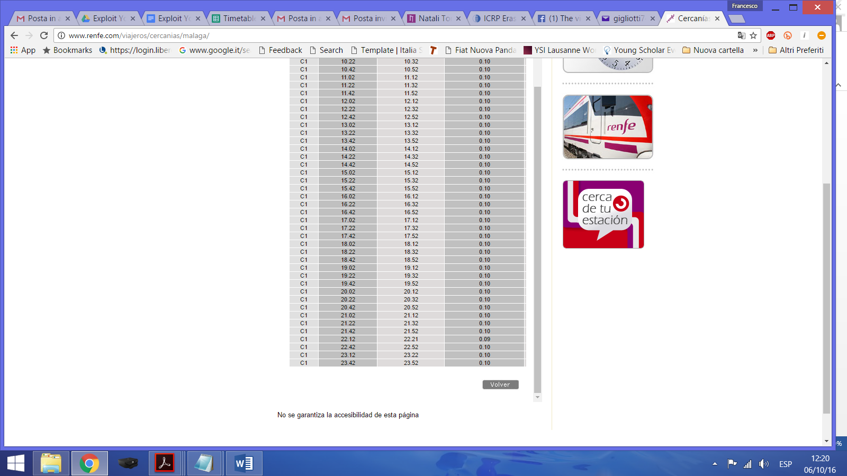

From Train station exit Torremolinos to Hotel Natali (750mt)

Address: Calle Hoyo, 28, 29620 Torremolinos, Málaga, Spain

Ask people or just take a look up to the Buildings and you will see Hotel Natali.

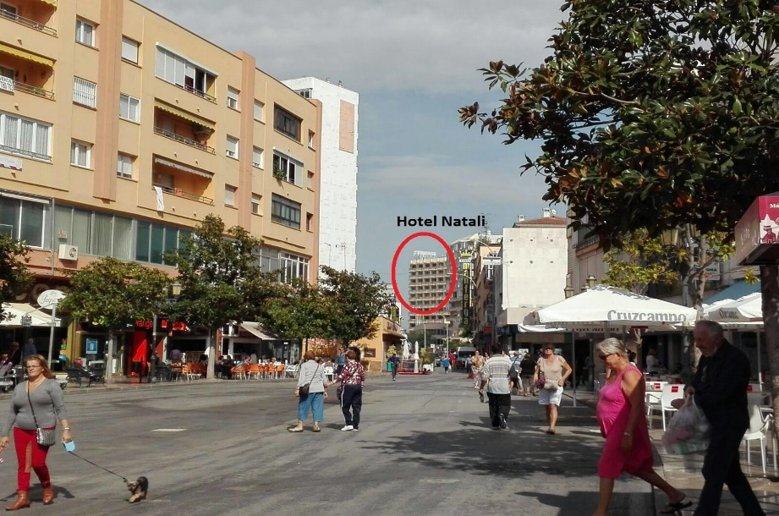

RECOMMENDATION: If you arrive in Madrid airport, you can take a bus from the ESTACIÓN DE AUTOBUSES DE MADRID (ESTACION SUR) who will bring you directly in front of the hotel. (direction: Madrid – Torremolinos) Here you can check the schedule.

- VISIBILITY & DISSEMINATION
According to Erasmus+ grant agreement and the signed memorandum of understanding, it is the responsibility of each partner to assure the visibility, dissemination and exploitation of results;

13. CONTACT: mobility-office@projuven.org

SPECIFIC PERSON:
- Debora Dimova mobility-office@projuven.org
For any questions about the project, your travel, your stay, your good mood and entertainment during the project, we are here to support you. In order to facilitate the communication, please include “EUnique project” in your e-mail subject together with a specific description of your request.
We advise you to use e-mail as the primary mean of communication. Believe it or not, it is the fastest way to reach us! :)

